Email to [ceu@fire.nsw.gov.au](mailto:ceu@fire.nsw.gov.au)

**1. Details of Residence**

Address of residence:

Suburb: Council (if known):

|  |  |  |  |  |  |
| --- | --- | --- | --- | --- | --- |
| Type of residence: | Single dwelling (i.e., house)  Boarding house, guest house or hostel (Class 1b ≤ 300 m² and ≤12 residents)  Building containing 2 or more separate Sole Occupancy Unit (SOUs) (Class 2)  Boarding house, guesthouse, hostel, hotel, or backpacker accommodation (Class 3) | | | | |
| Type of construction: | | Approximate size: | m | x | m | |

What fire protection equipment (if any) is installed in the residence?

|  |  |  |
| --- | --- | --- |
| Smoke alarm (battery operated) | Smoke/heat detector (hard wired) | Fire Sprinklers |

Which of the following utilities are connected in the residence?

|  |  |  |
| --- | --- | --- |
| Electricity | Gas | Telephone |

**2. Fuel Load Hazard**

According to Frost’s clutter image rating scale (see overleaf), how would you rate the fuel load hazard?

|  |  |  |
| --- | --- | --- |
| Living room: | Bedroom: | Kitchen: |

How does the fuel load hazard impact on access and egress to the residence?

|  |  |  |  |
| --- | --- | --- | --- |
| Easy to enter | Slightly impaired | Moderately impaired | Severely impaired |

Please provide details:

**3. Submitted by (optional)**

|  |  |
| --- | --- |
| Name: | Contact details: |

Address or organisation:

If you are a firefighter, please provide service number and station no:

**Example of Frost’s clutter image rating scale for living room**

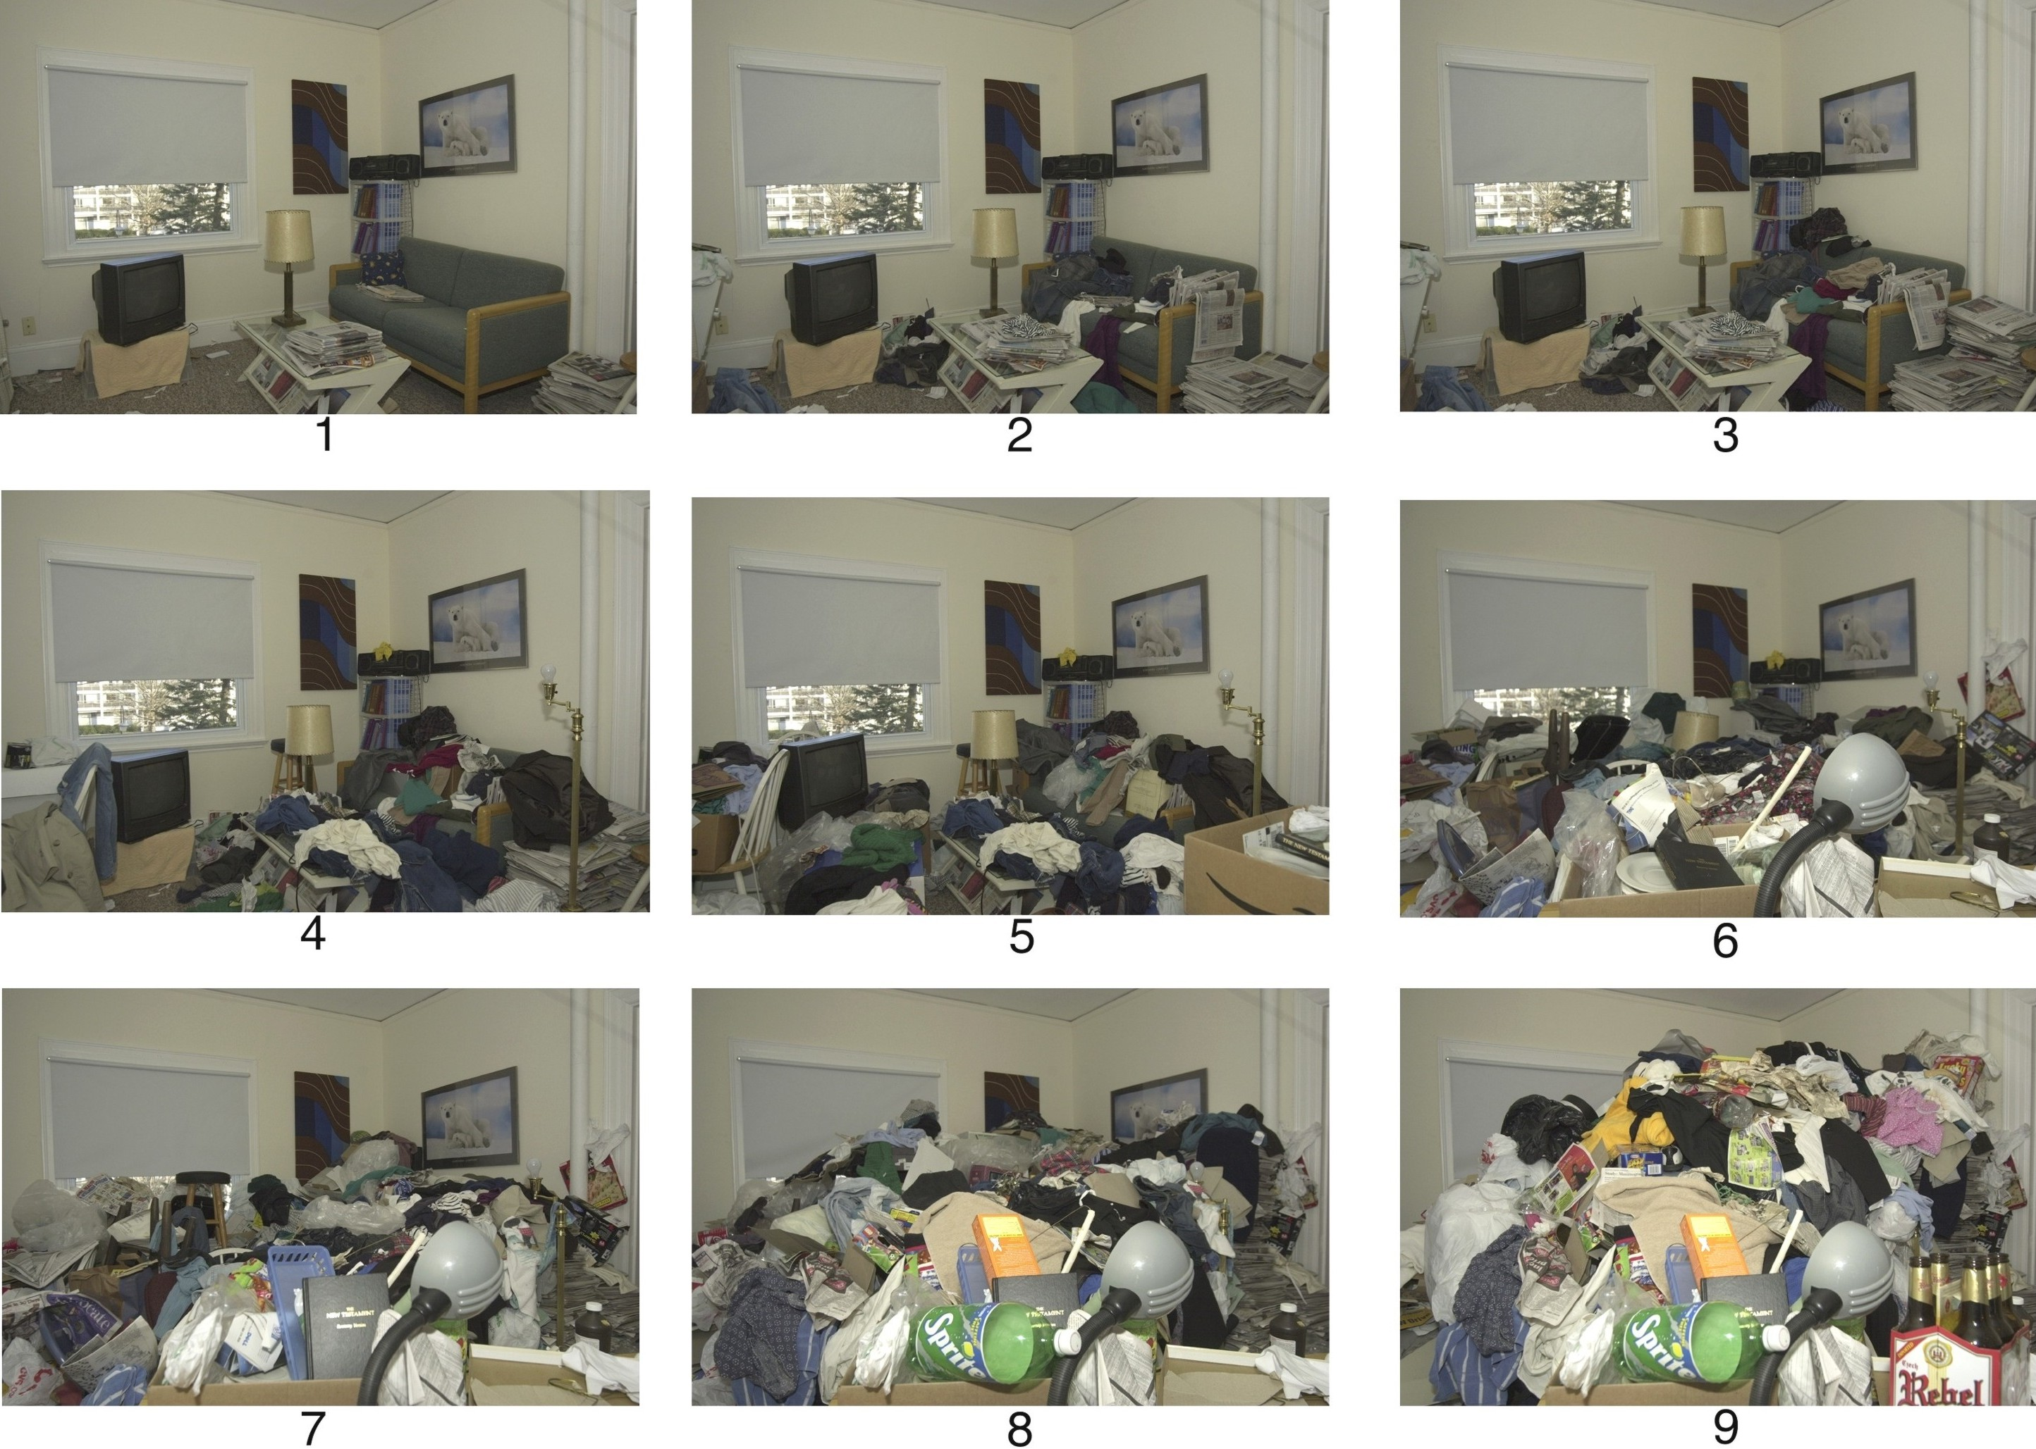

**Example of Frost’s clutter image rating scale for bedroom**

